RE: International Sport Business Program

Dear (INSERT SPECIFIC NAME),
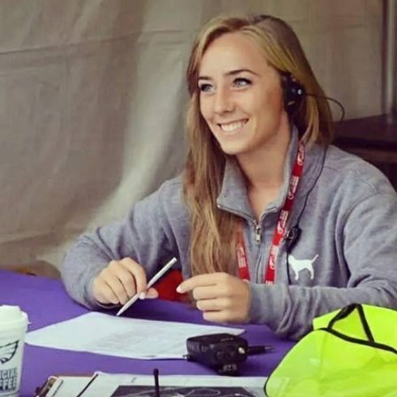
I want to share amazing news with you. I have been selected to participate in Living Sport’s International Sport Business Program in Athens, Greece this summer. My application was one of hundreds submitted, and I am so excited that I was selected to participate. This will be an incredible opportunity for me!
CHANGE TO YOUR PHOTO

During this ten-day trip, myself and other selected participants will receive the opportunity to work on the staff of Oceanman – the only international open-water swimming competition for elite and amateur swimmers which is held in 35 countries!

We will have the opportunity to study sport through a local professional team, Olympiacos F.C., and venues such as the Spyros Louis Olympic Stadium and Karaiskakis Stadium. I will also attend numerous skills workshop sessions throughout the program which are led by sport industry professionals. We will visit famous areas and attractions such as Ancient Olympia, the Acropolis and the Parthenon to learn about the history and culture of Greece. Leaving this experience, I will have also met a new network of sport industry professionals that could help further my career for years to come.

This is a great opportunity to grow both personally and professionally, but I still have much work to be done. To take advantage of this offer, I must raise (AMOUNT YOU WANT TO RAISE) to cover program expenses. I ask you to consider becoming a sponsor of mine. Any amount will get me closer to my goal. I appreciate in advance the support you can provide to me, and will keep you up-to-date on my progress.

Sincerely,
BECOME A SPONSOR:
TO DONATE BY CHECK, send to:
Name
Address
City, State, Zip

DEADLINE DATE:

(YOUR SIGNATURE HERE)

TYPE YOUR NAME
TYPE YOUR E-MAIL
TYPE YOUR PHONE NUMBER

Living Sport Program Overview:
www.livingsport.com

